**Temperature Analysis**

In order to secure backing with W.Avy and additional equity partners, temperature statistics were analyzed for months of June and December for various years. Utilizing temperature data, this factors into consideration of multiple islands in Hawaii with their set temperatures.

Analyzing data comparing months of June and December proved useful to understand differences in temperature broken down to mean, standard deviation, min, max, and various interquartile ranges. Comparing these two months, June had more record counts for recorded data with 1700 vs December with 1517. Having more records to utilize will improve the confidence of the standard deviation and variance metrics, but this number of volume, differences can be marginal with limited impact.

As expected, the summer month of June, had warmer temperatures than its winter December counterpart. Standard deviation of error was higher in December as anticipated due to the sample size, and overall had a mean difference of 3.9 degrees Fahrenheit between June and December. Max temperature deltas had a difference of 2 degrees Fahrenheit, min had a delta of 8 degrees Fahrenheit, and the interquartile percentages were comparable in trend with the other metrics as shown in Figures 1 and 2.

To provide additional insights for W. Avy and additional equity partners, an additional task to recommend would be to show trends of each month (June and December) through matplotlib visualizations not for the aggregate of all years but split with these key metrics by year to show cooling and warming trends. Another recommendation to utilize is the amount of precipitation that is directly correlated with temperature readings. The final recommendation recommended is correlating ice cream sales along with factors of precipitation and temperature readings for a few years with direct and indirect competitors in the market survey.

Utilizing these ideas into the analysis will showcase past, current, and future trends to anticipate for the success of the business. The next step, with investor approval, will be to aggregate, consolidate, and analyze competitor sales with key factors of precipitation and temperature using weathermap APIs, and Temp data scraping to ensure a more informed decision for this business proposal.

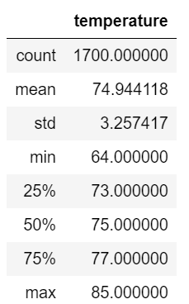

**Figure 1: June Temperature Statistics**

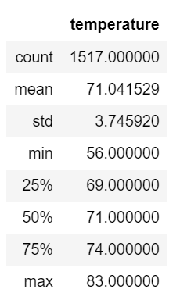

**Figure 2: December Temperature Statistics**